# Group 47

Team Member Names:

1. Jason Roberts
2. James Weber
3. Garrett Goodwin
4. Ryan Radtke
5. Johnny Duong

# Project Overview

## Summary

The SunDevil Pizza software system consists of three major devices to help automate and simplify the ordering process. The three devices will take the form of a desktop application. The system’s first device will give customers a platform they can use to order pizza in a painless process, keeping up with modern expectations for an easy, enjoyable user experience. The second device will be a platform which an order processor will use as a tool to help them efficiently and effectively process orders and take care of other workplace responsibilities. The third device will be a platform chefs can use to easily take processed orders, and mark them complete when they are finished cooking. The primary goal of the software development project is to give users an easy, painless, and effective system to achieve their goals.

## Customer Experience and Supporting Software

The customer will use the desktop application to order pizza. This process will be streamlined through four incremental pages: landing page, pizza type and topping selection page, checkout page, and status page.

### Landing Page

The landing page will give the customer a first impression of their SunDevil Pizza ordering experience. The customer’s attention will be drawn to the primary call to action button to create an order. Other options the customer can take from here are hyperlinks to a login page. The customer can also be taken to the order status page if they have an order in progress. This page will have general store information on it to include: hours of operation, customer service phone number, and address.

### Login Page/Create Account

The user will be able to navigate to this page from the landing page when they choose to login or create an account with the store. Creating or logging into an account will allow the user to see the order status of their pizza. They can also save billing information to make future orders more convenient.

### Pizza Type and Topping Selection Page

The customer will select pizza type, toppings, and quantity for each unique pizza they order. The available pizza types will be pepperoni, vegetable, and cheese. There will be an image of each pizza type with its respective selectable option. The available toppings will be mushrooms, onions, olives, and extra cheese. The customer may add more than one topping. There will be an image of each topping with its respective selectable option. The customer will be able to see a visualization of pizza they are creating, showing the pizza type and each added topping. The customer will be able to see their subtotal at all times while they make their selections. The price increase from adding toppings will also be visible by the toppings. Prices, available pizza types, and available toppings will be parameterized and configurable via a documented API.

### Checkout Page

This will be where the customer can review their order and make changes as necessary as well as input payment information and finalize their order. The payment information can either be an ASURITE ID, or credit card information. If any information is incorrect, the user will be notified and the order will not go through. If the user is logged in and has saved billing information, this can be applied automatically. Once the customer has finished their order and confirmed payment this page will transition to the order status page

Order Status Page

If the guest is logged into their account they can view in-progress orders and see the status of the pizza. Status updates include: “accepted” (payment has been processed), “ready to cook” (order processor has approved the order), “cooking” (pizza is being cooked), and “ready” (order is ready for pick up). Each stage will have an approximate time associated with it that can be dynamically changed based on current volume and busyness of the store. If the order has not started cooking yet, the customer can cancel their order and be refunded. When the customer’s order status is complete, they will receive an email notification.

## Order Processor Experience and Supporting Software

The order processor will have orders presented to them in a readable, informative format. The orders will be presented chronologically, with the first placed orders at the top and last placed orders at the bottom. The orders will show quantity, toppings and pizza types, status, price, order ID, and time placed.

## Chef Experience and Supporting Software

The chef will have orders presented to them in a readable, informative format. The chef will see two sets of orders: orders they are cooking and orders they have not yet started cooking. The section with orders that have not yet started cooking will be below the orders that the chef is cooking. Within both sections, orders will be presented chronologically, with the first placed orders at the top and last placed orders at the bottom. If multiple chefs are present, the chef will not see orders that other chefs are cooking. The orders will show the time they were placed, and the type and toppings for each pizza ordered. The time will change colors based on length since placed (green to yellow to red) to help the chef visually prioritize orders.

# User’s Guide/Walkthrough

## Landing Page

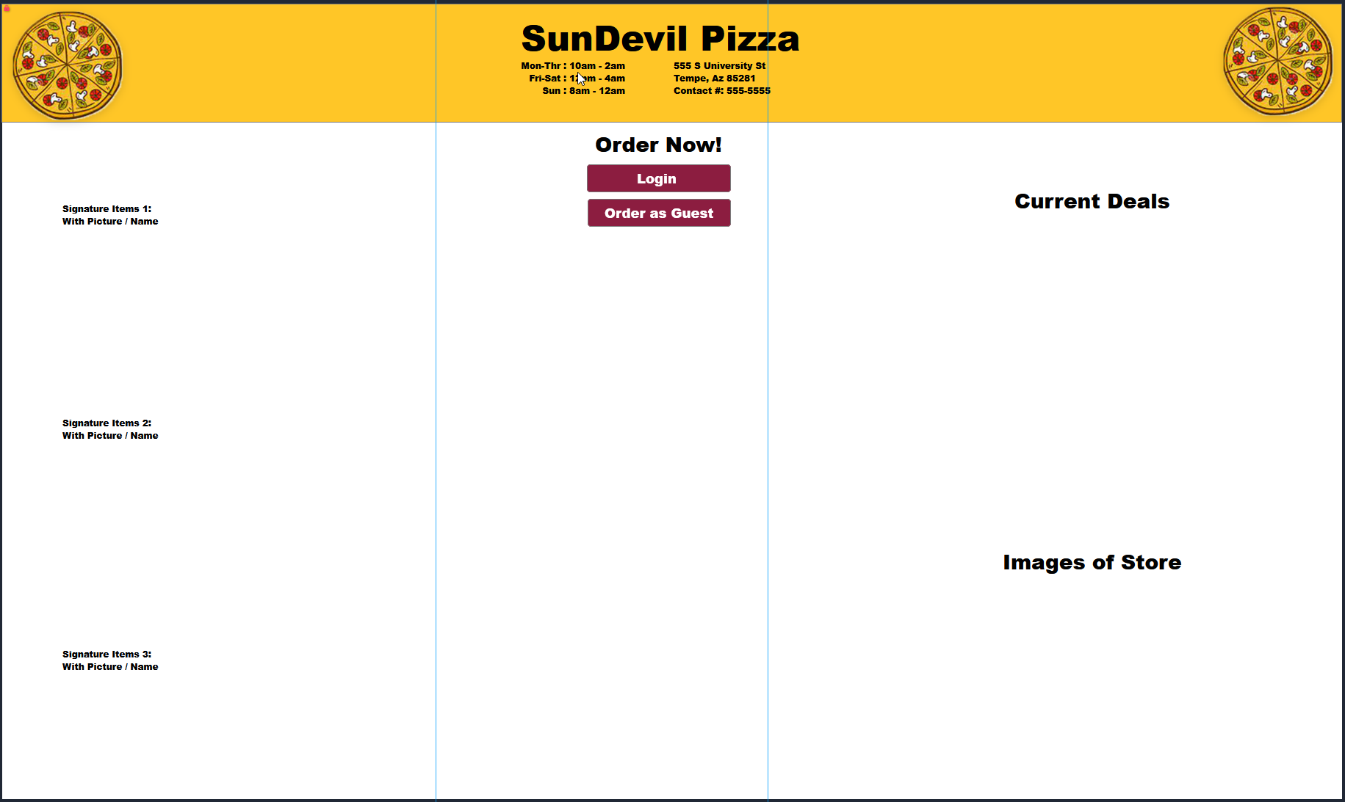

The customer enters the landing page upon opening the application. They see the call to action buttons clearly in the center of the screen. They also see images of signature items to help them get hungry, important store information, and deals.

Login Page

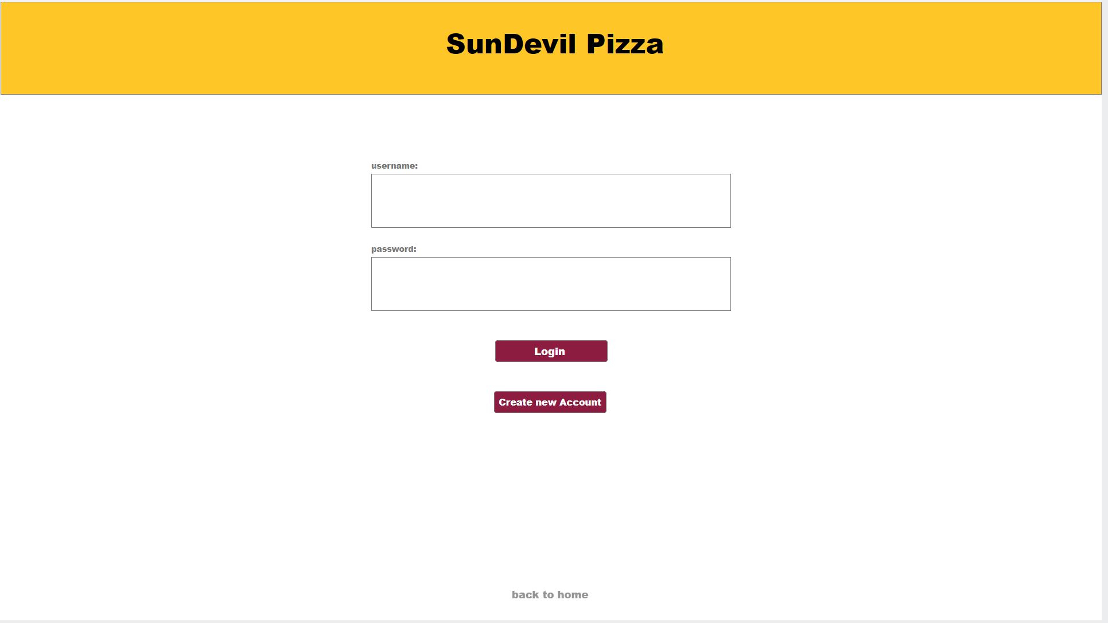

On the login page the user can sign into the application with their username and password. They also have the option to create a new account or go back to the landing page by clicking the ‘back to home’ button.

New Account Page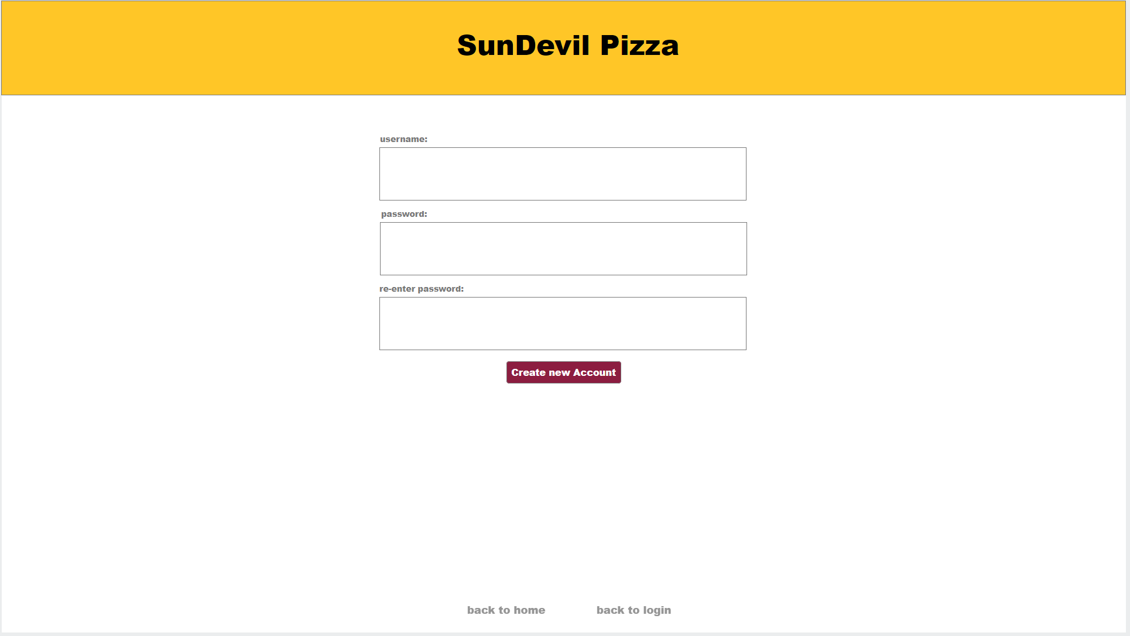

## On the new account page the customer can input their username, password, and re-enter their password to create a new account. From this page they can also use the ‘back to home’ button to go back to the landing page, or use the ‘back to login’ button to go back to the login page.

## 

## Pizza Type and Topping Selection Page

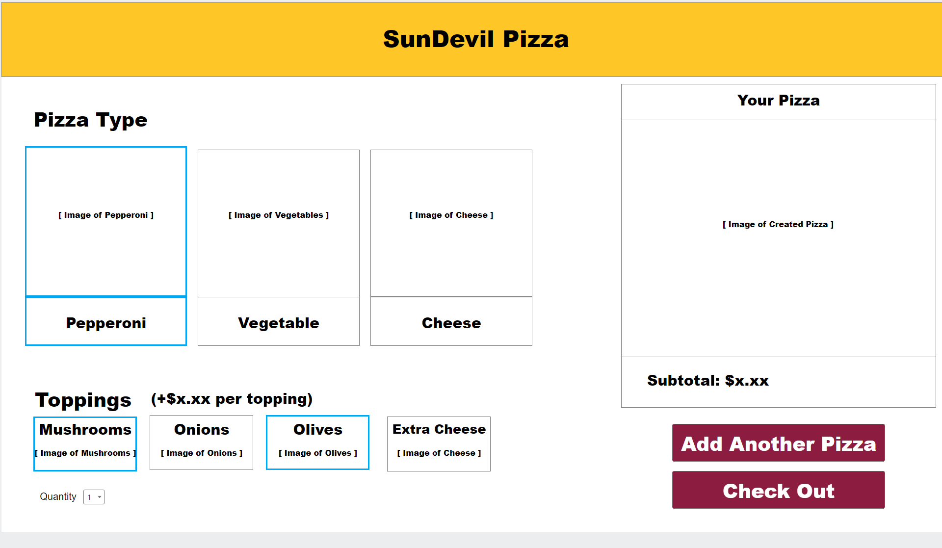

On the pizza types and toppings selection page, the customer will be allowed to create a personalized pizza via the toppings and pizza types interactable buttons. Once the customer is satisfied with their selected choice, the user will be able to add the pizza to their order and will be prompted to either add another pizza to the order, or check out. Once a pizza is added to the customer’s order, the price will be displayed.

Checkout Page

On the checkout page the customer can see the pizzas they ordered. It is broken down into the type of pizza, toppings, and quantity inside the What was Ordered section. The customer can also see the price of each pizza broken down along with the total cost inside of the receipt section. This page also includes an area for the customer to input their card information and then either confirm checkout or go back to the Pizza Type and Topping Selection Page.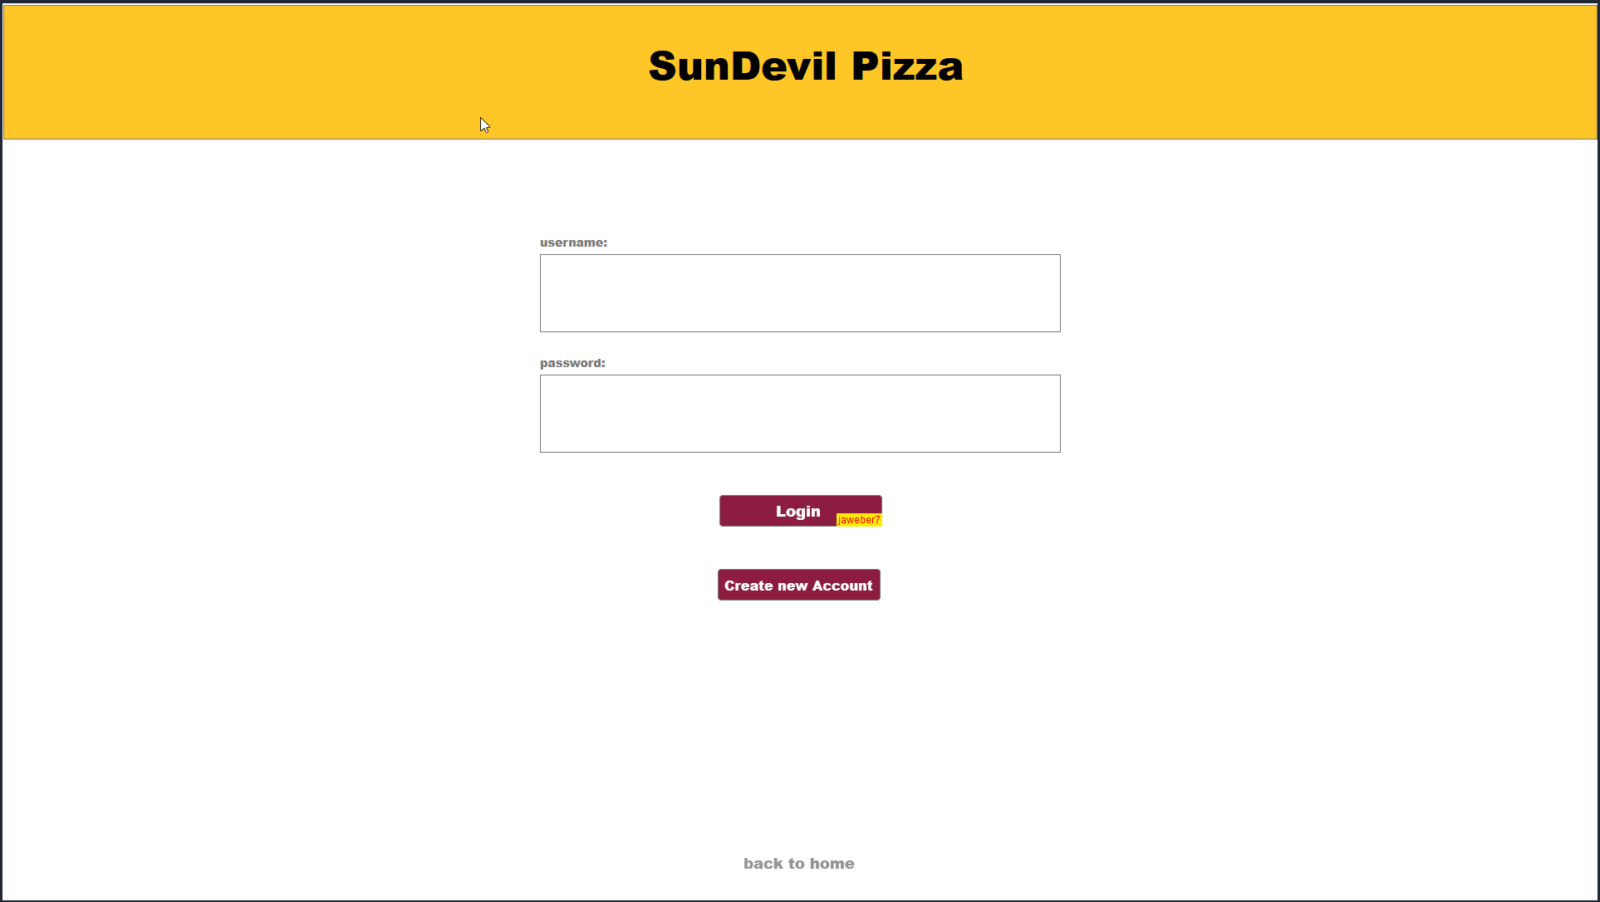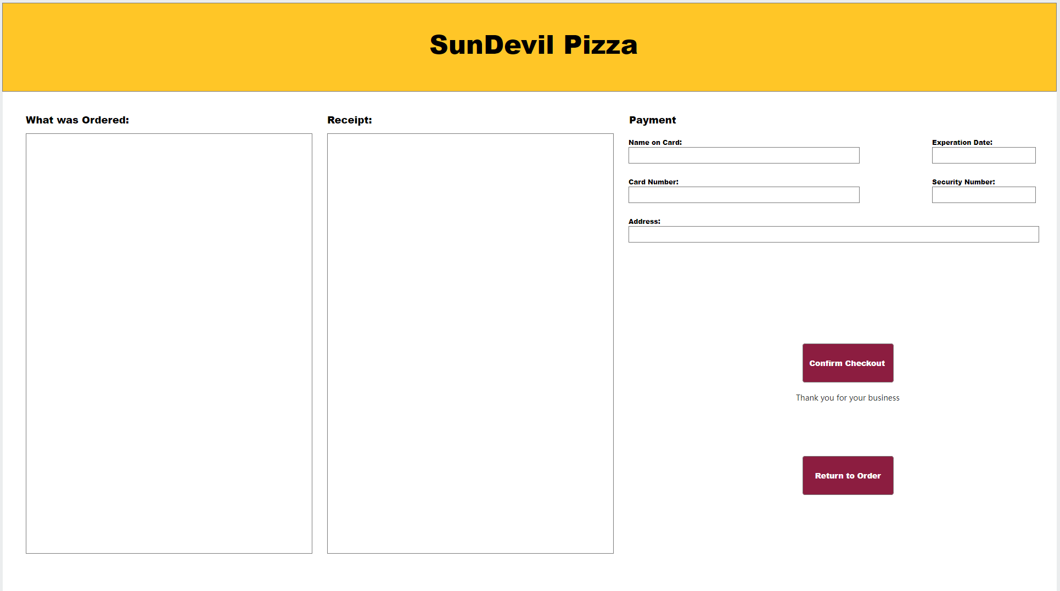

## Status Page

In the order status page, an updated image displaying the status of the customer’s food order will be displayed to the user. The user will also be shown the time at which they first placed the order as well as the customer’s selected food delivery method. 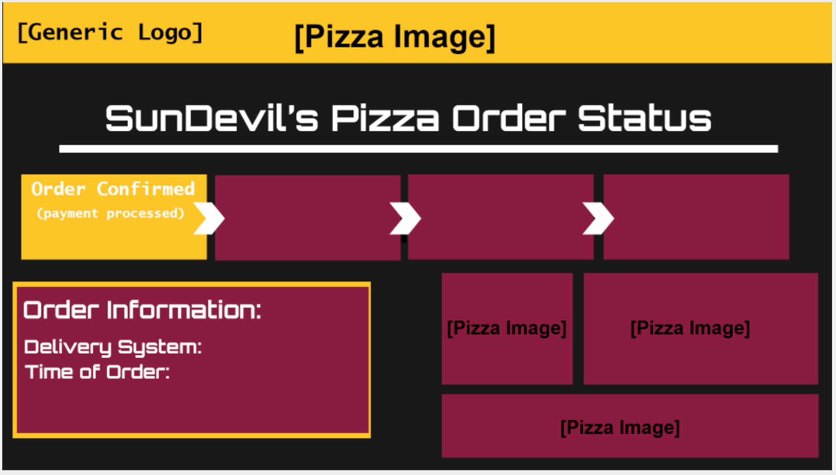

## Order Processing Page

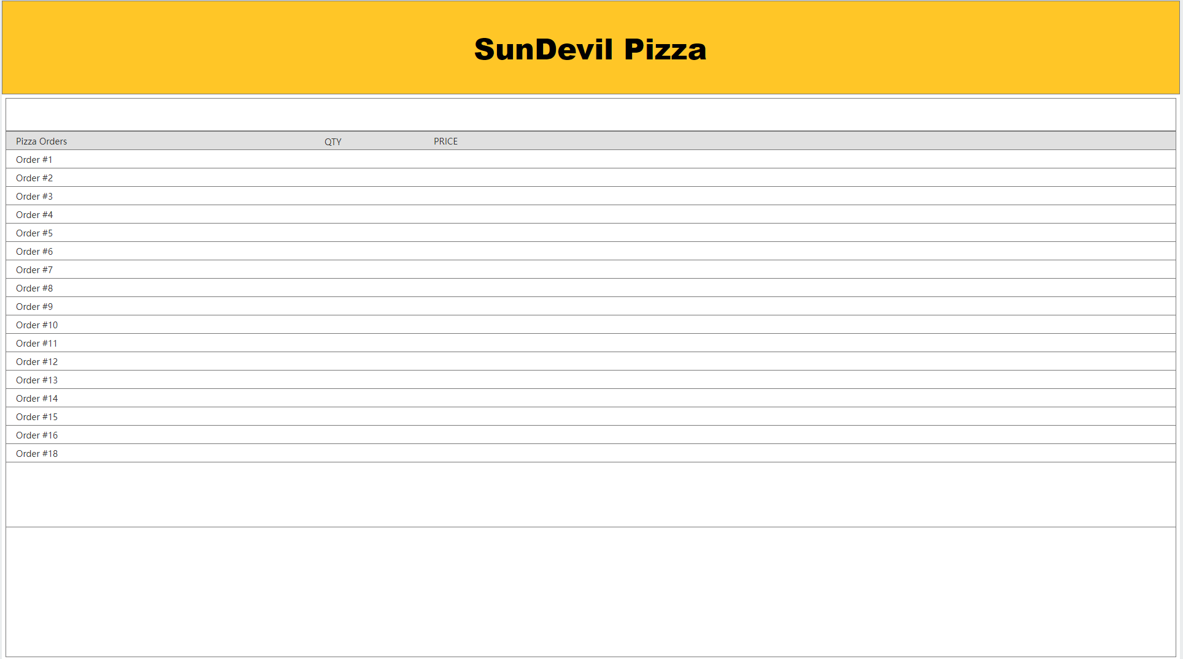

The order processor page shows the orders of the customers in order based on time. The orders include the pizza type and toppings added as well as the amount of pizzas ordered. It also shows the price of the order, when order was placed, the status of the order, and the order ID.

## Chef Page

Chefs are able to access the chef’s page to see the orders placed by the customers. The page shows whether or not the order is being cooked at the moment as well as the type of pizza that the customer has ordered. The time is also shown to the chef, which the time changes the color to help chefs with prioritization.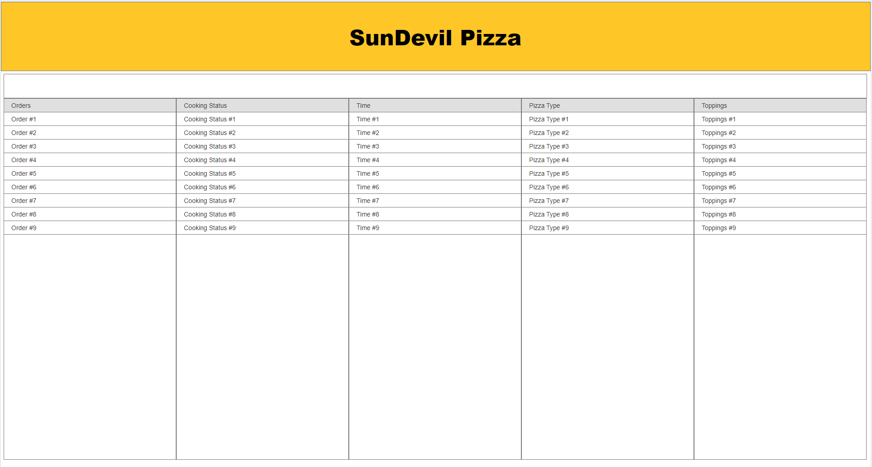

# Credit Sheet

| Team Member Name and ASU ID | Team Member Contributions |
| --- | --- |
| Jason Roberts | 1223795560 | Editing/GUI Page Creation |
| James Weber | 1220618282 | Project overview, User’s Guide/Walkthrough |
| Garrett Goodwin |1219736830 | User’s Guide/Walkthrough, Mock up |
| Ryan Radtke | 1223359969 | User’s Guide/Walkthrough, MockUp |
| Johnny Duong | 1219131095 | User’s Guide/Walkthrough, Mockup |